ISFET Technology
By Ad van den Broek
The ISFET (Ion Selective Field Effect Transistor) methodology for ion measurement is developed on the basis of the MOSFET (Metal Oxide Silicon Field Effect Transistor). The first attempts to use the ISFET as pH sensor were made in 1970. The basic principle underlying the MOSFET is the control of a current flowing between two semi-conductor electrodes. Drain and source are placed on the same element, with a third electrode, the gate, between them.
The metallic gate electrode is insulated against drain and source by means of silicon dioxide and can only influence the drain-source current electrostatically. The extremely high input resistance of the gate electrode means that no large input power is required to control this current.
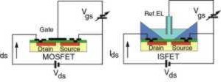
Figure 1: Normal MOSFET compared with ISFET
The MOSFET's gate consists of a metallic coating and is used as an electrode to control the drain-source current through the external potential Vgs.
In the case of the ISFET the metallic gate is replaced by a special oxide-coated gate, that is sensitive to hydrogen ion concentration. When immersed in a liquid, the electrical circuit Vgs is closed with the reference electrode and the hydrogen ion concentration in solution can influence the drain-source current. The fundamental ISFET pH measuring system is shown in figure.2.
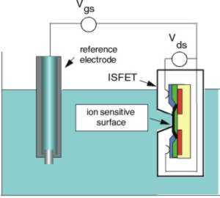
Figure 2: Schematic representation of an ISFET pH measuring system
Ions or other charged particles do not have to pass through the ion sensitive membrane. The membrane's control of the strain current is solely based on electrostatic effects. Many different types of oxide coatings were tested in order to generate an ion-selectivity, including silicon dioxide, silicon nitride and tantalum oxide.
SENTRON uses aluminium oxide coatings in its pH sensors for the gate electrode since this gives the best results as an H+ selective sensor. This technique is firmly integrated into a silicon sensor manufacture, together with an additional "protection electrode", improving the performance of the sensor.
This by SENTRON patented principle ensures a considerably higher stability under exposure to incident light and even very high electrostatic discharges. (see also figure 3)
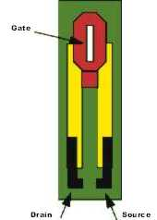
Figure 3: Schematic representation of the SENTRON pH sensor
The fundamental working of every MOSFET is the electrostatic control of the current flowing between source and drain via the potential of the gate electrode, of which the latter in the ISFET is mainly determined by the hydrogen ion concentration (activity) present at this gate.
In the actual sensor the drain current value is kept constant by means of electronic feedback. If the pH value of the solution changes, the potential of the gate changes and therefore also the drain current. At the same time the electronic feedback causes the voltage supply to the reference electrode to re-adjust in such a way, that the drain current is kept constant.
The value for Vgs is the casual measurement parameter of this system, being a measure for the pH, pH change.
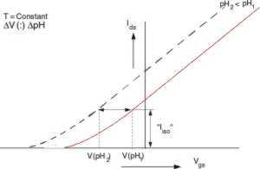
Figure 4a: Vgs for two different pH values at constant temperature
Looking at figure 4a, D Vgs directly represents the pH (change) between pH1 and pH2. In figure 4b a point can be seen at which the temperature has no influence on Vgs. (isothermal point).
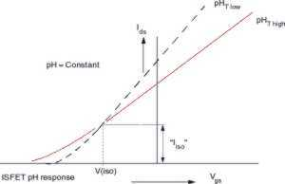
Fig. 4b: Vgs for two different temperatures at constant pH value
Keeping the drain current Ids at this "Iiso" level will theoretically mean temperature independent measurements. In practice however this value must be and is determined for every individual sensor manufactured to an accuracy of better than 10-6 A, resulting in very accurate pH measurements.
The use of this micro solid state sensor technology enables rugged, glass free probe type designs, varying in shape and dimensions, offering a wide range in which for every type of application the most optimal selection can be made.

